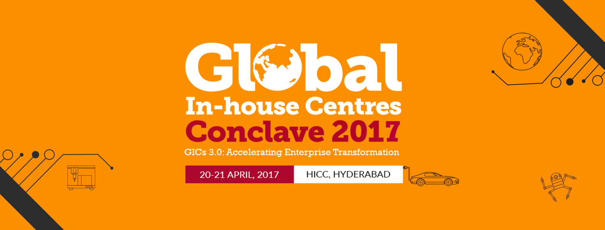

NASSCOM has negotiated special room rates for conference delegates. Please connect with following hotels for more information.

Shilpi Gupta
Ibis Hyderabad HITEC City
Mobile: +91 7337367628
Email: H6589-sl1@accor.com

Download Room Reservation Form

Apurva Jogi
Sheraton Hyderabad Hotel
Mobile: +91 9100122988
Email: apurva.jogi@sheraton.com

Download Room Reservation Form

Madan Mohan Domala
Hotel Radisson
Mobile: +91 9963338456
Email: madan@rdhchyd.com / resv@rdhchyd.com

Ashish Ray
Hotel Novotel HICC
Mobile: +91 9966024009
Email: ashishr@hicc.com or H6182-re@accor.com

Download Room Reservation Form

